**Blending Document 5**

**Provisional Blend No**

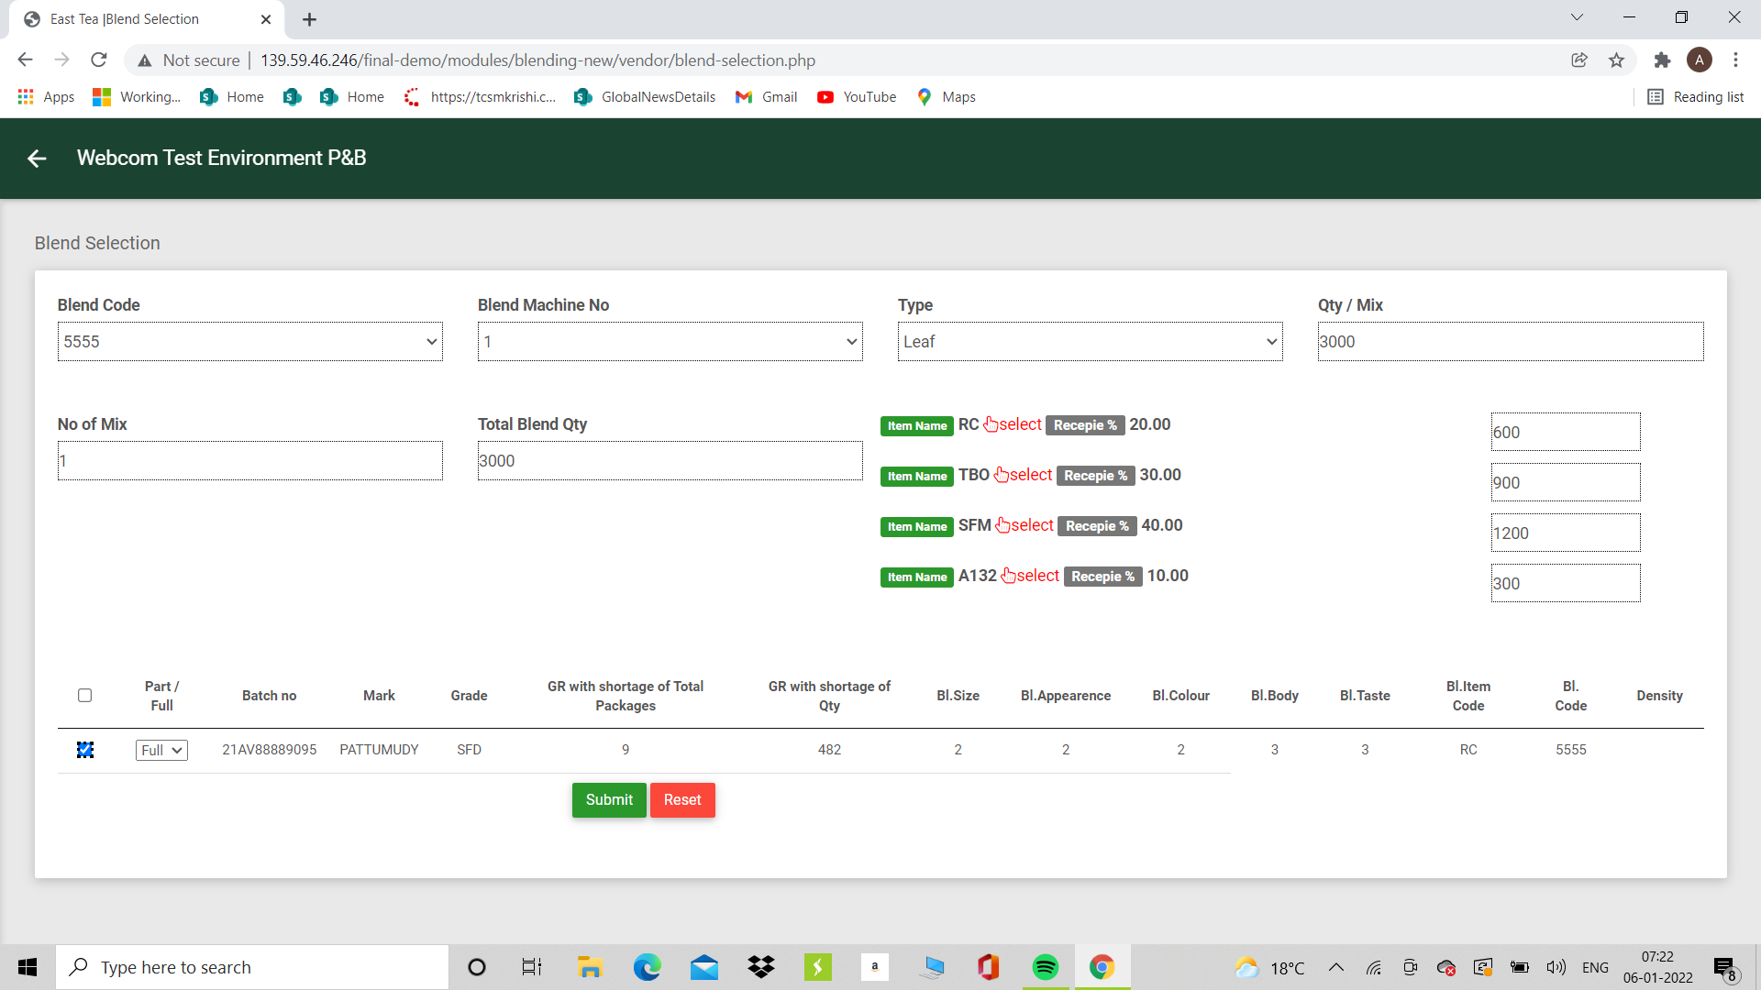

Provisional Blend No

In the Blend Entry Screen a Provisional Blend No is to be provided which will auto generate the Number. If for example a provisional blend number 1 exists the next number will be 2 etc.  
Done

**Qty Selected for item and Total**

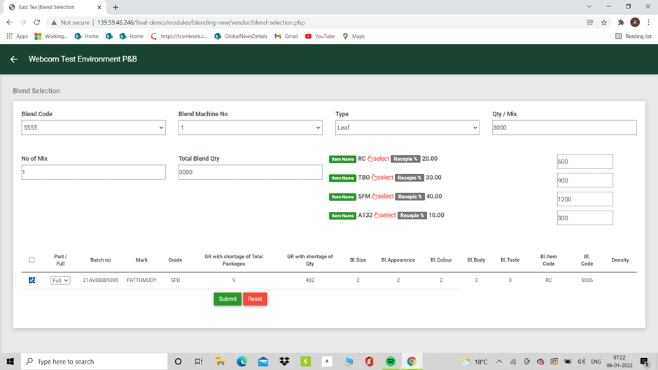

Item Tot

Blend Totals

As Qty is being selected the Qty selected should be updated in the main screen against the item total and blend total.

Done

Part lot Edit to **GR with shortage of Total Packages**

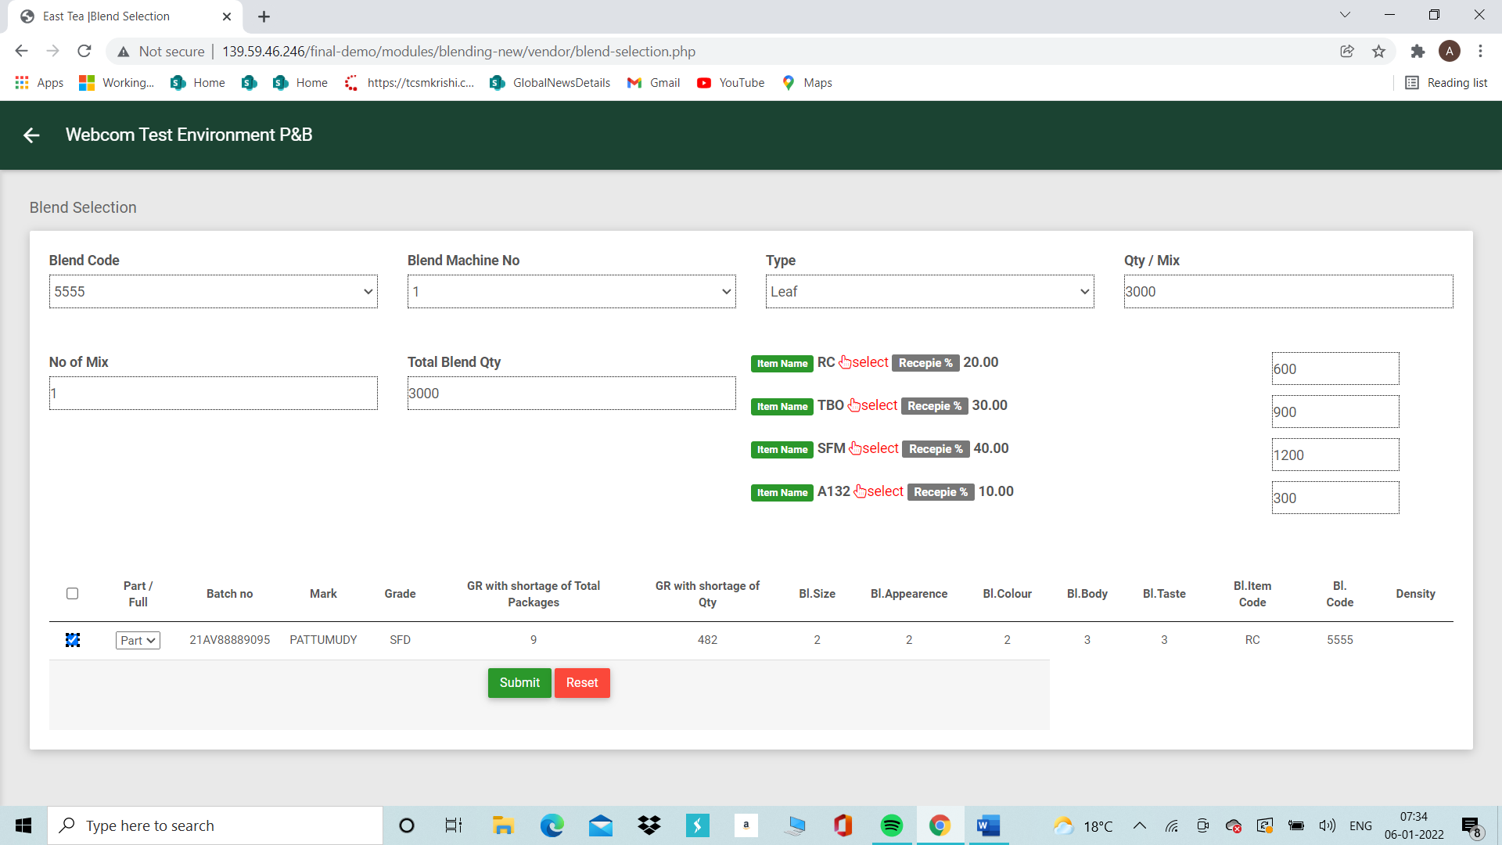

When a part lot is selected the field with GR with shortage of Total Packages has to be edited.

When edited the field **GR with shortage of Qty** has to be updated with

**GR with shortage of Total Packages multiplied by the Effective Net Kg**

**These changes made should have a different colour**

**Saving of the records of the item would not be allowed if the changes are not made to the batch no where there is a partial lot flag but no changes made.**

**Saving the Provisional Blend in a Provisional Blend Table**

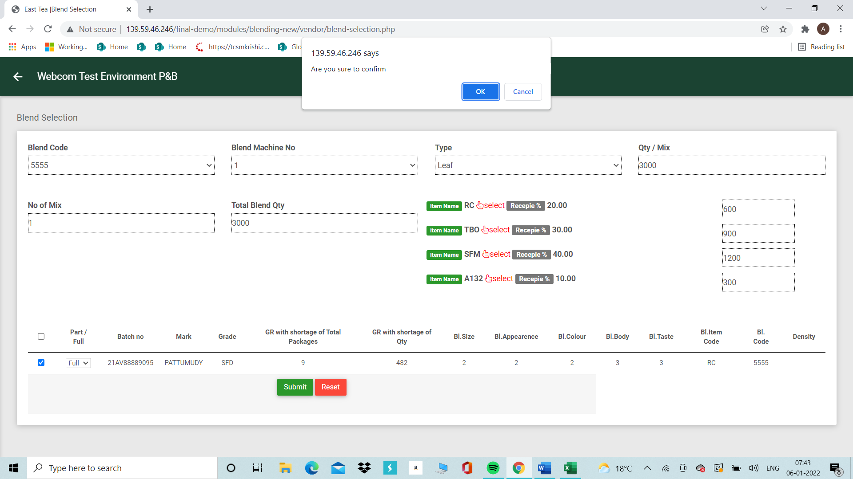

**When the item is submitted all the records should be saved in a Provisional Blend table against the Provisional blend No.**

After each submission is saved the screen should return to the provisional blend no to add the other items

A Blend complete button should be available which will save all the records and close the screen

Blends should be available to edit in a different tab Provisional Blend Edit

In the edit mode the whole blend should be available for edit and new batches can be added from available stocks in the blend table.

In the edit mode batches can be deleted or qty changed.

**Critical Requirement**

**Any batch selected for the Provisional Blend either in Full or Part should be blocked in the Blending table for further selection**

**One batch can be selected only for one Provisional blend either in full or part**

**The blocking of the batch should happen immediately on saving of the Item in the provisional Blend sheet**

**If in the edit mode a batch no is released this batch should be unblocked in the Blending table.**